Pipelined RISC-V Processor

Jomana Amin
Faculty of ITCS
Nile University
Cairo, Egypt
j.hussein2327@nu.edu.eg
Rania Hassan
Faculty of ITCS
Nile University
Cairo, Egypt r.ossama2334@nu.edu.eg
Adham Mohamed
Faculty of ITCS
Nile University
Cairo, Egypt
a.ahmed2283@nu.edu.eg Yomna Saad
Faculty of ITCS
Nile University
Cairo, Egypt
y.medhat2362@nu.edu.eg Mohamed Salama
Faculty of ITCS
Nile University
Cairo, Egypt
m.hesham2359@nu.edu.eg

Abstract—This report describes the design, implementation, and simulation of a pipelined RISC-V processor by using Verilog. The processor implements a five-stage pipeline: IF, ID, EX, MEM, and WB as well as handles R-type, I-type, load/store, branch instructions. The developed processor also uses forwarding and hazard handling, which was tested through simulation to be executing instructions correctly. The obtained CPU works correctly and with higher throughput compared to the single-cycle design [1], [2].

Introduction
Pipelining is an established approach to improving instruction throughput in most modern CPU architectures [2]. A pipelined RISCV processor divides the execution into five stages, namely Instruction Fetch, Decode, Execute, Memory access, and Write-Back. Introduction of pipeline registers between stages allows many instructions to proceed to the execution step simultaneously, therefore increasing CPU performance. RISC-V is an ideal architecture for pipelining because it has a clean and modular instruction set with instructions of fixed length, which enables very straightforward instruction decoding and ALU control [1], [3]. In this project, a 5-stage pipelined RISC-V processor is implemented with hazard detection, forwarding, and branch-flushing mechanisms necessary for correctness.

Datapath Diagram
The datapath follows the standard five-stage pipeline:
IF Stage: Fetches instructions from instruction memory and increments the program counter (PC).
ID Stage: Decodes instructions, reads registers, and generates control signals.
EX Stage: Performs ALU operations, including arithmetic, logical, and shift operations.
MEM Stage: Accesses data memory for load/store instructions.
WB Stage: Writes back results to the register file.
Pipeline registers (IF/ID, ID/EX, EX/MEM, MEM/WB) separate each stage and carry instruction data and control signals. Hazard detection and forwarding units prevent data hazards and ensure correct instruction sequencing.
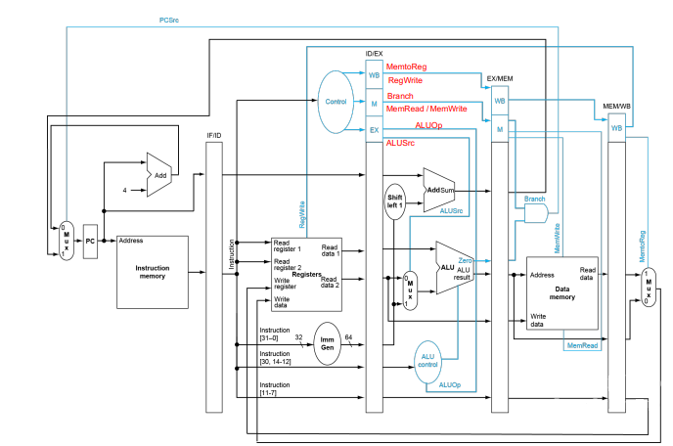

Fig 1 Datapath Diagram

Design Methodology & Modules explanation
The project began by designing each module independently, then integrated them into the pipeline and those modules are:

Arithmetic Logic Unit (ALU)
The ALU is the part of the CPU that does math and logic. In our pipelined processor, it works in the Execute (EX) stage.
It takes two numbers (A and B) and a 4-bit control signal (ALUCtl) that tells it what operation to do.
The ALU supports all the required RISC-V operations:
- Math: add, sub
- Comparison: slt (sets result to 1 if A < B, using signed numbers)
- Logic: and, or, xor
- Shifts: sll (shift left), srl (shift right logical), and sra (shift right arithmetic)
For shift instructions, it uses only the lowest 6 bits of the second number (B[5:0]) as the shift amount — which is correct for 64-bit RISC-V.
The ALU also outputs a Zero flag that becomes 1 when the result is 0. This is used by the branch logic to decide if a beq (branch if equal) instruction should jump.
The ALU is combinational, meaning it has no clock or memory — it just calculates the result instantly based on its inputs. This is perfect for one stage of a pipeline.
The control codes (ALUCtl) it expects come from the ALU Control Unit, and we made sure our encodings match exactly (see Table 3).
ALUCtl | Operation | Instructions Supported
0010 | A + B | add, addi
0110 | A – B | sub
0100 | (A < B) ? 1 : 0 (signed) | slt, slti
0000 | A & B | and, andi
0001 | A | B | or, ori
0111 | A ^ B | xor, xori
0011 | A << B[5:0] | sll, slli
1000 | A >> B[5:0] | srl, srli
1010 | $signed(A) >>> B[5:0] | sra, srai

Control Unit & ALU Control Unit
The main control unit generates primary control signals based on the opcode field of the instruction as well as the ALUOp code: RegWrite, MemRead, MemWrite, ALUSrc, MemToReg, Branch, ALUOp.
The ALU control unit receives the ALUOp signal from the Main Control Unit along with the funct3 and funct7 fields of the instruction. Based on these inputs, it generates the ALUControl signal, which directly specifies the arithmetic or logical operation to be performed by the ALU (eg. ADD, SUB, XOR… etc).

Table 1 Control Unit OPCode
Instruction Type | [0] | [1] | [2] | [3] | [4] | [5] | [6]
R-Type | 1 | 1 | 0 | 0 | 1 | 1 | 0
I-type | 1 | 1 | 0 | 0 | 1 | 0 | 0
Load | 1 | 1 | 0 | 0 | 0 | 0 | 0
Store | 1 | 1 | 0 | 0 | 0 | 1 | 0
Branch | 1 | 1 | 0 | 0 | 0 | 1 | 1

Table 2 Control Units’ Control Signals
Instruction Type | RegWrite | MemRead | MemWrite | Branch | ALUSrc | MemtoReg | ALUOp
R-Type | 1 | 0 | 0 | 0 | 0 | 0 | 10
I-Type | 1 | 0 | 0 | 0 | 1 | 0 | 11
Load | 1 | 1 | 0 | 0 | 1 | 1 | 00
Store | 0 | 0 | 1 | 0 | 1 | X | 00
Branch | 0 | 0 | 0 | 1 | 0 | X | 01

Register File & Immediate Generator
The Register File and Immediate Generator are key components of the Instruction Decode stage in the pipelined RISC-V processor. Register File provides two asynchronous read ports and one synchronous write port for 32 registers, with register x0 permanently hardwired to zero. Immediate Generater is a combinational unit responsible to correct extraction and sign-extension of immediate values from different RISC-V instruction formats, including I-type, S-type and B-type instructions such as addi, andi, xori, ori, ld, sd, beq, shift-immediates. Together, these modules supply the ALU with correct operands and immediates, ensuring proper execution of arithmetic, memory, and branch instructions.

Program Counter, Branch Logic & PC Update
The Program Counter unit holds the address of the current instruction and updates it in each clock cycle. Program Counter handles two cases. In the first case, it handles normal instruction and the PC is incremented by four to point in the next instruction. In the second case if the branch is taken the Program Counter is updated with a branch target address by adding the immediate offset from the instruction to the current Program Counter value. The Program Counter is updated in the rising edge of the clock cycle. The PC is initialized to zero using an asynchronous reset at the start of execution.

Pipelined RISC-V Processor (Top-Level CPU Module)
The purpose of this module is to implement and integrate a five-stage pipelined RISC-V processor that executes 64-bit RISC-V instructions correctly and efficiently. The processor is designed to follow the classic pipeline stages: Instruction Fetch (IF), Instruction Decode (ID), Execute (EX), Memory Access (MEM), and Write-Back (WB).
The CPU is divided into five main stages to enable parallel instruction processing and high throughput:
1. Instruction Fetch (IF)
In this initial stage, the Program Counter (PC) provides the address to the Instruction Memory to fetch the next instruction. The PC is then updated—either incrementing by 4 for sequential execution or jumping to a target address if a branch is taken.
2. Instruction Decode (ID)
This stage serves as the logic hub between fetching and execution. The primary operations include:
- Decoding: Breaking down the instruction into its opcode, register addresses ($rs1, rs2, rd$), and function codes.
- Control Unit: Generating control signals based on the decoded opcode to manage the rest of the pipeline.
- Immediate Generation: Extracting and sign-extending the immediate value from the instruction bits.
- Register Read: Accessing the Register File to retrieve data from the source registers.
3. Execute (EX)
This is where the actual computation occurs. The stage performs the following:
- ALU Control: Determining the specific operation (Add, Sub, Shift, etc.) based on the ALUOp signals.
- Operand Selection: Using a MUX to determine the second ALU input (either a register value or the generated immediate).
- ALU Operation: Performing the arithmetic or logical calculation.
- Branch Calculation: Computing the branch target address and evaluating the branch condition (e.g., zero flag for beq).
4. Memory Access (MEM)
This stage manages the interface between the processor and Data Memory:
- Load/Store Operations: Performing memory writes (sd) or memory reads (ld) based on the address calculated by the ALU.
- Branch Finalization: Passing the branch decision back to the PC logic to determine the next instruction address.
5. Write-Back (WB)
In the final stage, the results are committed back to the Register File:
- Result Selection: A MUX selects whether to write the ALU result or the Data Memory output to the destination register (rd).
- Register Update: If the instruction requires a write (e.g., addi or ld), the data is stored in the Register File, completing the instruction cycle. For sd or branch instructions, no register update is performed.

This module serves as the top-level CPU datapath, responsible for coordinating all submodules, managing data and control flow between pipeline stages, and ensuring correct instruction execution under pipelining constraints.
Data hazards are handled using a dedicated forwarding unit sub-module, which detects dependencies between instructions in the EX, MEM, and WB stages and forwards the most recent computed values directly to the ALU inputs, eliminating unnecessary stalls. Control hazards are managed using a simple branch prediction strategy that assumes branches are not taken; the program counter increments by four by default, while branch target addresses and conditions are computed during the execution stage. If a branch is resolved as taken, the pipeline is flushed and the PC is redirected to the correct branch target, ensuring correct flow. This design was fully implemented, simulated, and verified in Vivado using RISC-V test programs, producing the expected results.

Results & Simulation Waveforms

Verification Methodology
Verification was conducted using a custom testbench and a targeted RISC-V assembly program designed to exercise all pipeline features.
- RAW Hazard Test: Used add and and instructions immediately following addi to trigger Forwarding Unit logic.
- Branch/Control Test: Used a beq instruction to verify the jump to the L1 label and ensure the flush signal prevented the execution of the "fall-through" instruction.
- Memory Test: Used sd and ld instructions to verify the data path between the processor and the Data Memory module.Test cases were turned into machine code in hexadecimal and preloaded in the Instruction memory. Then a test bench ran the test cases and displayed the results, which were successfully passed, and expected outcomes were achieved.
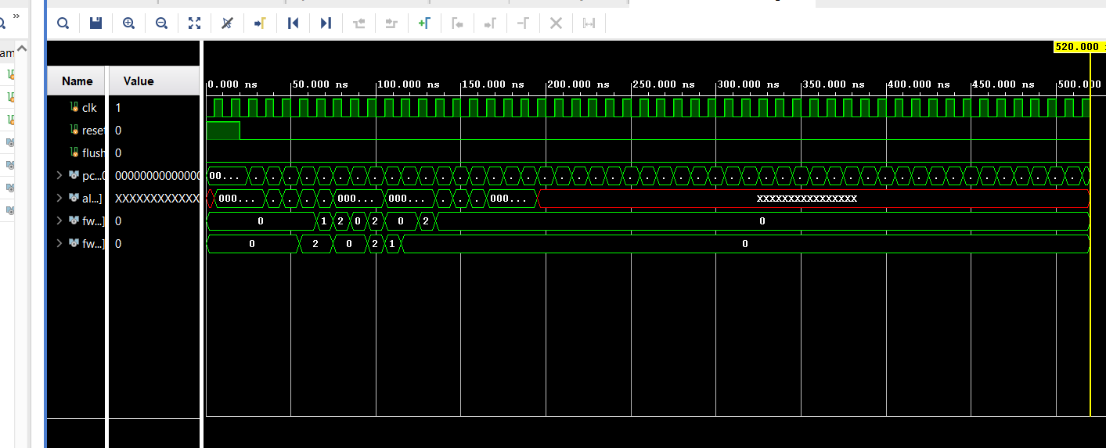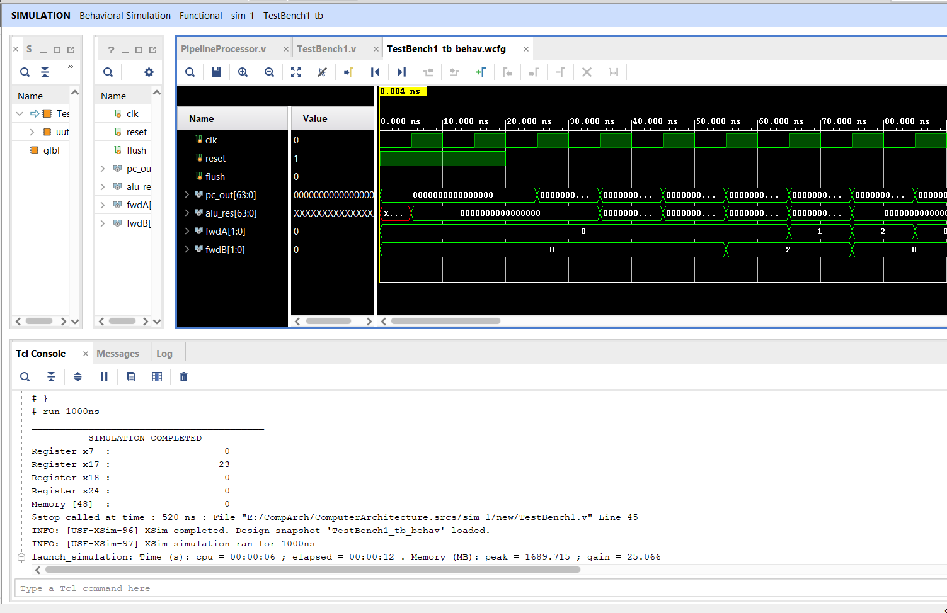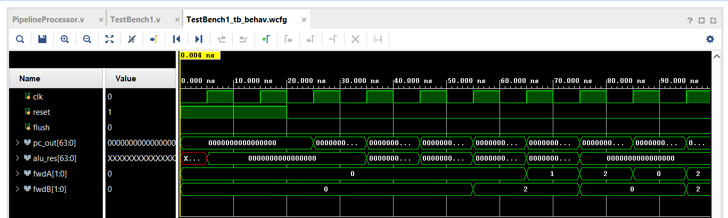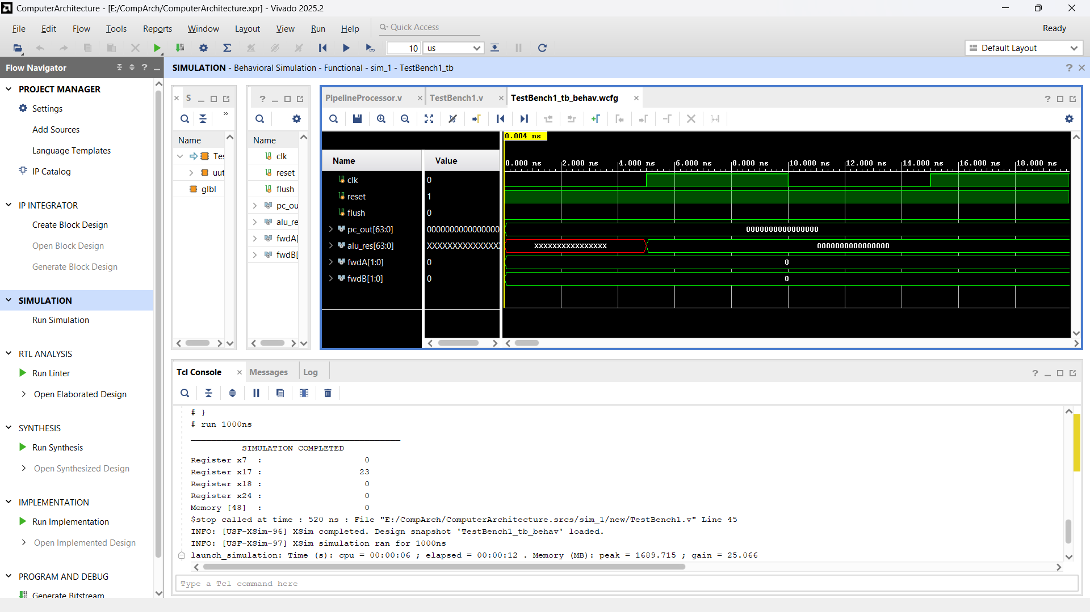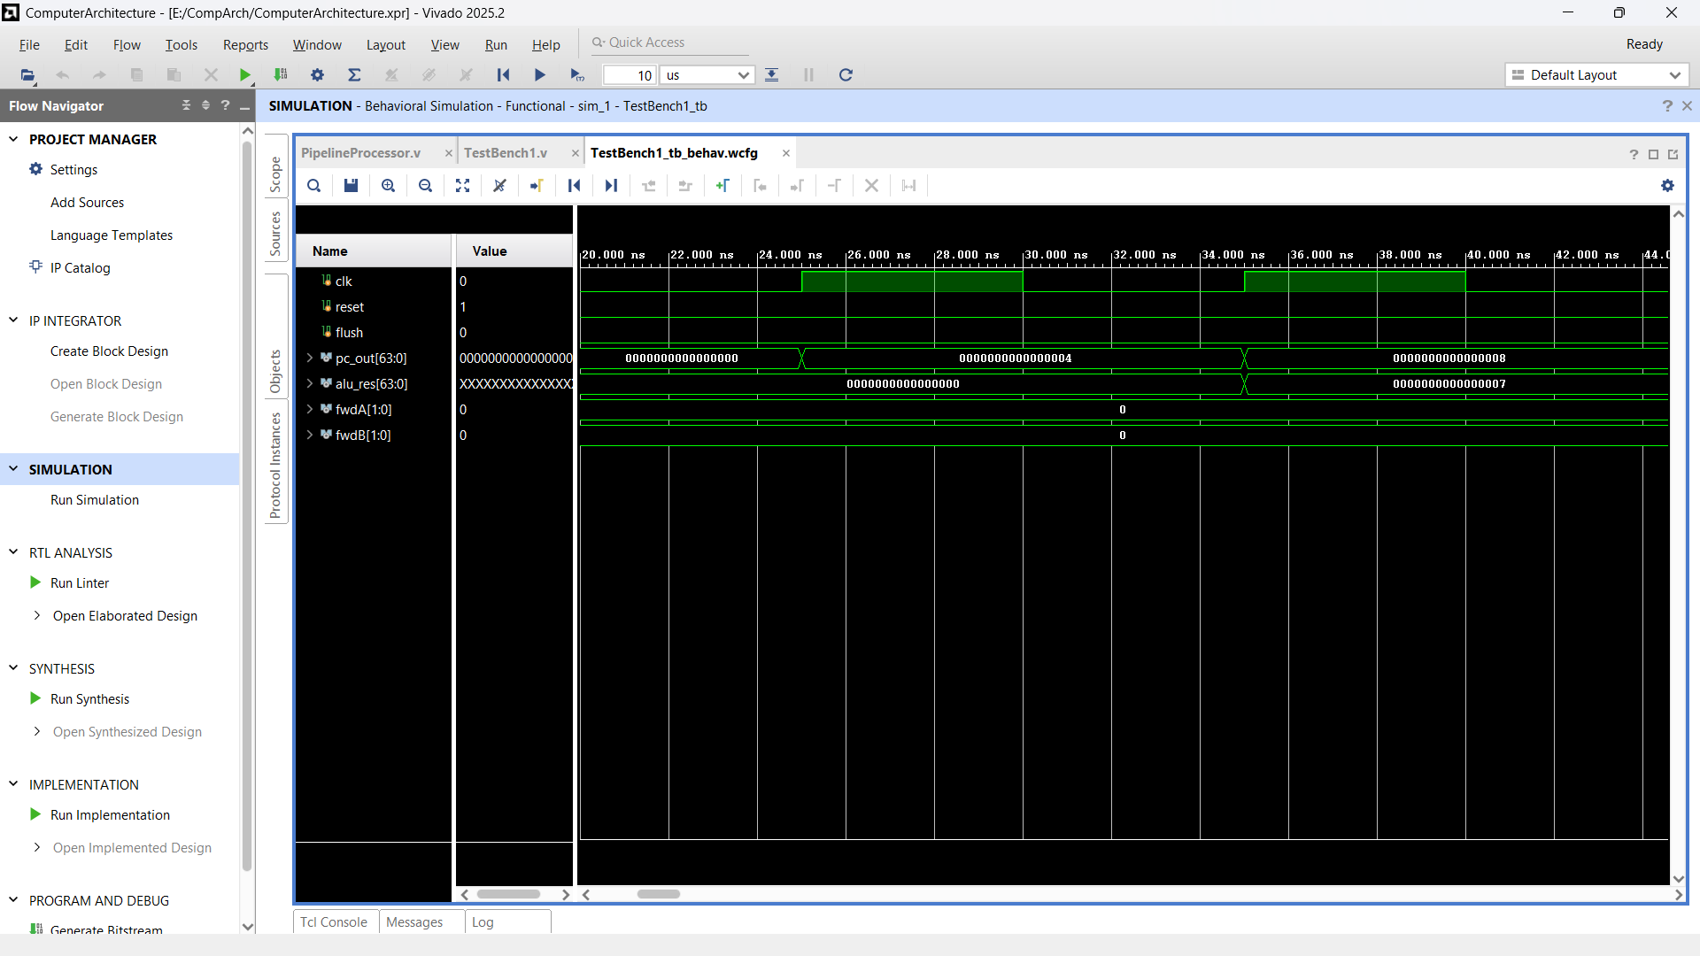

Conclusion
The project was designed and implemented to form a RISC-V processor. The modules include ALU, Control Unit, Register File, Immediate Generator, Instructions, Data Memories, and Program Counter (PC) with branch handling logic. The project was developed and tested individually and then integrated together to form a complete RISC-V processor datapath. Moreover, the processor implements the five stages pipeline which are IF, ID, EX, MEM, and WB, and it handles data and control hazards.

References
- RISC-V ISA Specifications, https://riscv.org/specifications/
- Hennessy, John L., and David A. Patterson. Computer Architecture: A Quantitative Approach, 6th edition, 2017.

- Patterson, David A., and John L. Hennessy. Computer Organization and Design RISC-V Edition, 2020.

